Ohio Edison, The Illuminating Company, Toledo Edison

OH Web Portal User Administrator Guide

Table of Contents
Background ……………………………………………………………………………………………………………………… 3
Web Portal Access ……………………………………………………………………………………………………………. 3
Supplier Log In …………………………………………………………………………………………………………………. 4
Administrator Responsibilities …………………………………………………………………………………………….. 5
View, Create, Edit, Remove Users ………………………………………………………………………………………. 5
View User …………………………………………………………………………………………………………. 5
Create User ………………………………………………………………………………………………………. 6
Edit User ………………………………………………………………………………………………………….. 7
Remove User ……………………………………………………………………………………………………. 7
Deactivate Users ……………………………………………………………...………………………………………………. 8
Attest ………………………………………………………………………………………………………………………………. 9
Activity Log ………………………………………………………………………………………………………………………. 9
Single User – Single Request (SU-SR) Access …………………………………………………………………….. 10
Single User – Single Request (SU-SR) Usage Information ……………………………………………………. 13
Exporting SU-SR Data ……………………………………………………………………………………………………… 15
Logging Out …………………………………………………………………………………………………………………… 17

Background

The web portal implementation was proposed in response to the desire expressed by the Commission in the March 26, 2014 Retail Market Investigation (“RMI”) Order. Companies included as part of fourth Electric Security Plan (“ESP IV”) application, filed August 4, 2014 based on the testimony of the utility. Commission decisions in this proceeding did not modify web portal proposal.
The portal requirements include:
- Customer Information (Customer Name, Service Address, Billing Address, Email)
- Account Information (20-Digit EDI Enrollment Number, Account Number, Meter Number/Cycle/Type/Interval Indicator, Rate Code & Load Profile, Voltage)
- Usage Information (12 months of Consumption/Demand/Interval data, Current & Future NSPL/PLC values)
- Other Information (Indicators for Shopping, Budget Billing, Smart Meter, Net Metering)
- Other Functionality (Need to collect and store letters of authorization for 3 years)

Web Portal Access

If you are a supplier with an active Ohio administrator, you will be given access to the portal at go-live, October 11, 2018. If you do not have an active administrator, then you will need to designate an Administrator to complete and submit the following forms:
- Request a New User ID and Password Form
- Non-Disclosure Agreement
The forms can be found online at the following web URL
https://www.firstenergycorp.com/supplierservices/pa.html.

Once the applicable Electric Distribution Company is selected then select the hyperlink titled ‘Request New User ID and Password’ to download the applicable forms.

Forms can be attached and submitted using the web form at the following URL
https://www.firstenergycorp.com/supplierservices/contact-us-supplier.html.
Please use Request Type “User ID and Password.”

If the supplier operates in more than one state, each state will require a unique user id and password.
Note: If a new administrator will be assigned, it is important to request and submit new forms. This will prevent any confusion or security issues in the future.

Supplier Log In

To access the log in screen, the user should go to FirstEnergyCorp.com and select the ‘Suppliers’ option from the top right menu. From there, select Supplier Services, then supplier portal (Figure 1).

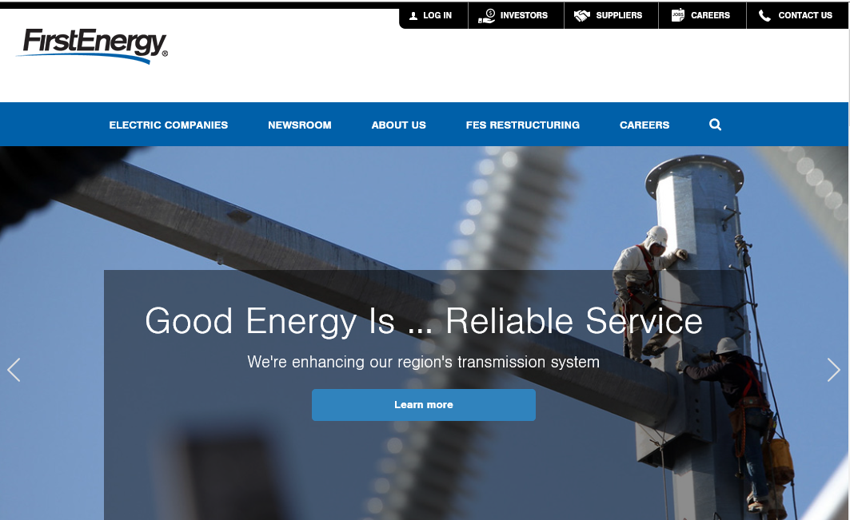
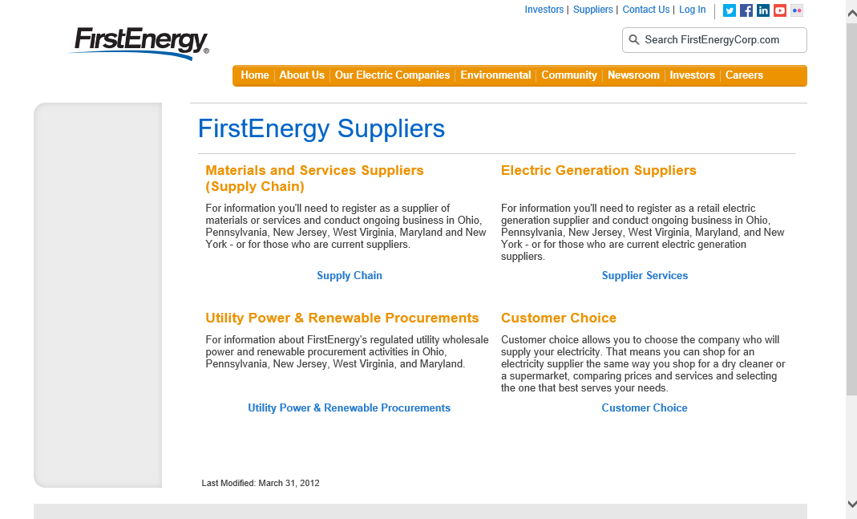
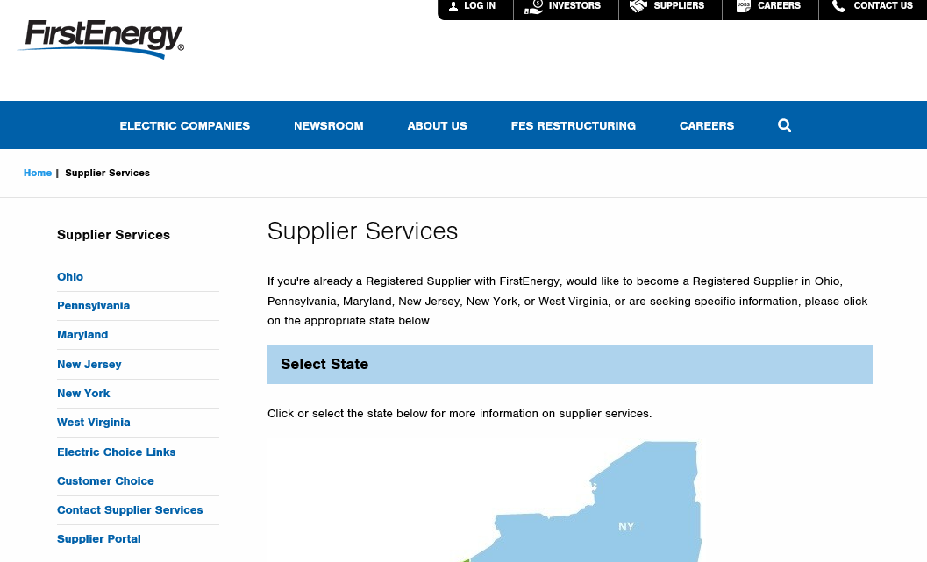
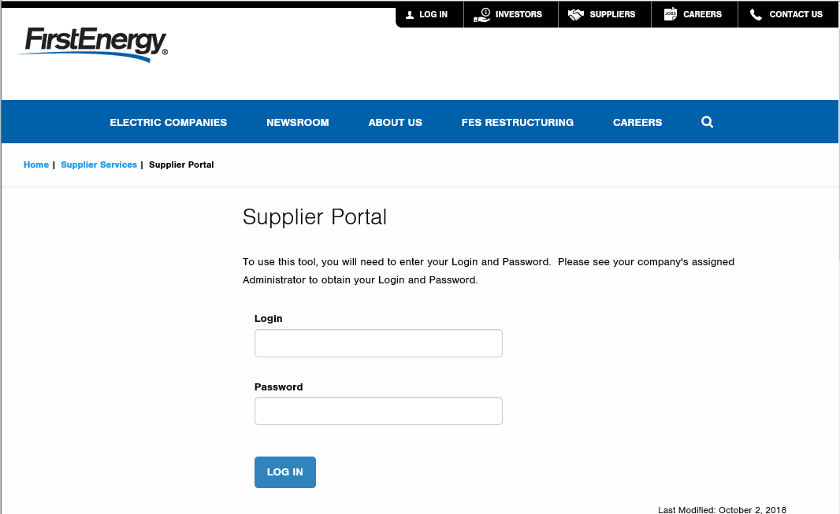
Customer Log In
Supplier Log In

Figure 1 Supplier Log In
Tip: Do not select ‘Log In’ from the top right menu of the FirstEnergy home page. This log in is intended for customer access to online billing.

For any issues with the logging in, please contact your system administrator. If the admin is unable to resolve, they will contact FE Supplier Services at (330)761-4348. It is the responsibility of the administrator to make this contact.

Once logged in, the password can be reset at any time by select ‘Reset Password’ from the left navigation menu (Figure 2).

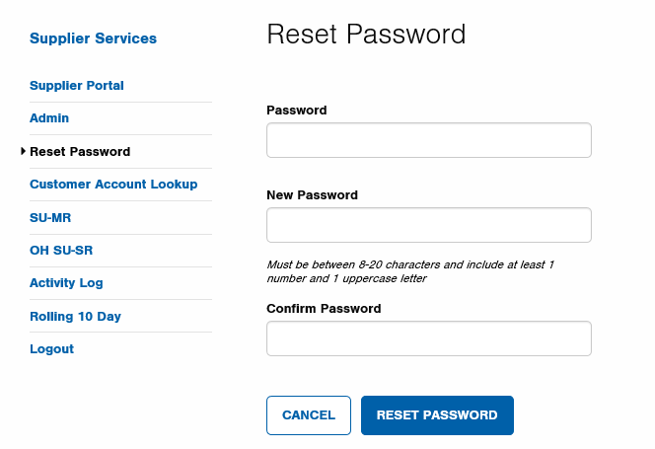
Figure 2 Reset Password

Administrator Responsibilities

The Administrator has certain responsibilities to ensure user lists are maintained and appropriate access is available. They will be able to:
- View, create, edit and remove users
- Deactivate user sessions if a user locks themselves out
- Attest that all users for their organization have proper access
- View an activity log of users and export the information to Excel

When an Administrator logs into the site they will be presented with the screen below (Figure 3). The ‘View Users’ button and ‘Attest Access’ button provide the administrator with the ability to perform the listed duties.

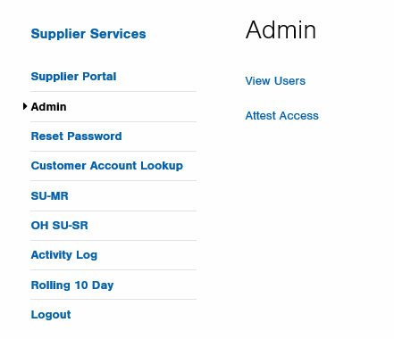
Figure 3 Admin Home Page

View, Create, Edit, Remove Users

View User
To view users for your organization, select ‘View Users’ from the Admin page. A table of users will be presented (Figure 4). This is where the administrator will add, edit, or remove users as needed.

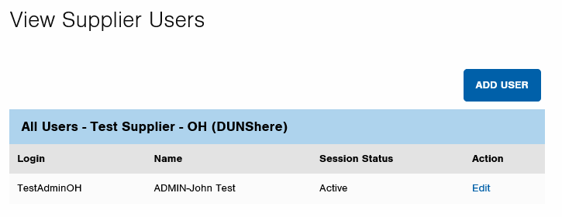
Figure 4 View Users

Create User
To add a new user, select above the user table (Figure 4).

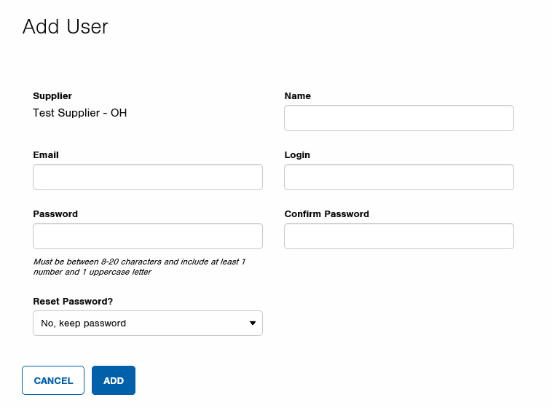
Figure 5 Add User
John Smith
JohnSmith@email.com
SmithJ
1xxxxxxX
1xxxxxxX

Fill in all the fields as shown in red above (Figure 5). The reset password option allows the admin to either keep the password entered or force the user to select their own (Figure 6):
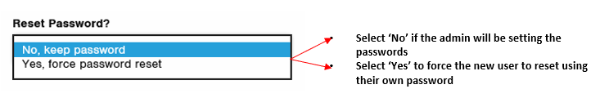
Figure 6 Add User Reset Password

Edit User
Once the new user has been added, all fields can be updated by selecting ‘Edit’ from the user table (Figure 7). Make the necessary changes and select ‘Save’.

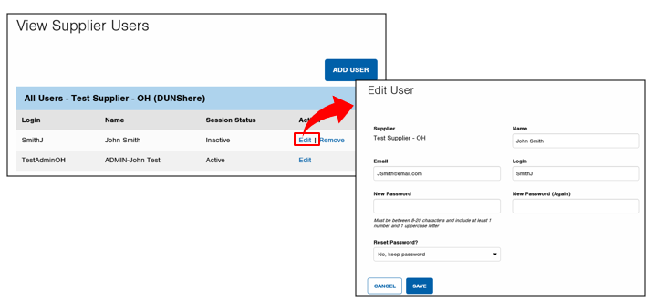
Figure 7 Edit User

Remove User
Selecting ‘Remove’ from the user table will result in a pop up asking if the user would like to proceed (Figure 8). Select to remove the user or to keep the user.

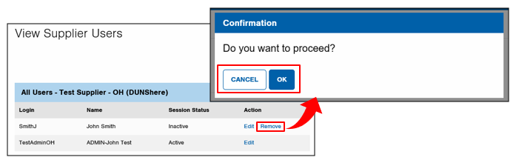
Figure 8 Remove User

Deactivate Users
If you forget to select logout at the end of a session the system will prompt a lock out of the user. If you have been inactive for 30 consecutive minutes the web portal will require the user to re-log in.

To deactivate a session because a user is locked out select ‘View Users’ from the admin page and you will be prompted with the option to Deactivate Session (Figure 9).

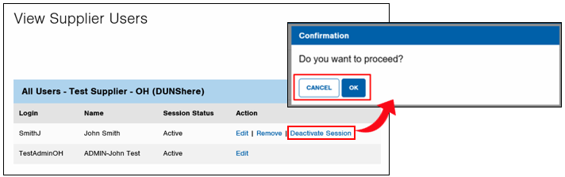
Figure 9 Deactivate Users

Select to deactivate the session, allowing the user to log in, or .
Note: If an Administrator is locked out they will need to wait 30 minutes before attempting to log back in.

Attest
Each administrator is required to validate the accuracy of the users of the portal. This is requested to ensure that the user list is complete and accurate. The administrator will be prompted on a quarterly basis to attest to the accuracy (Figure 10).

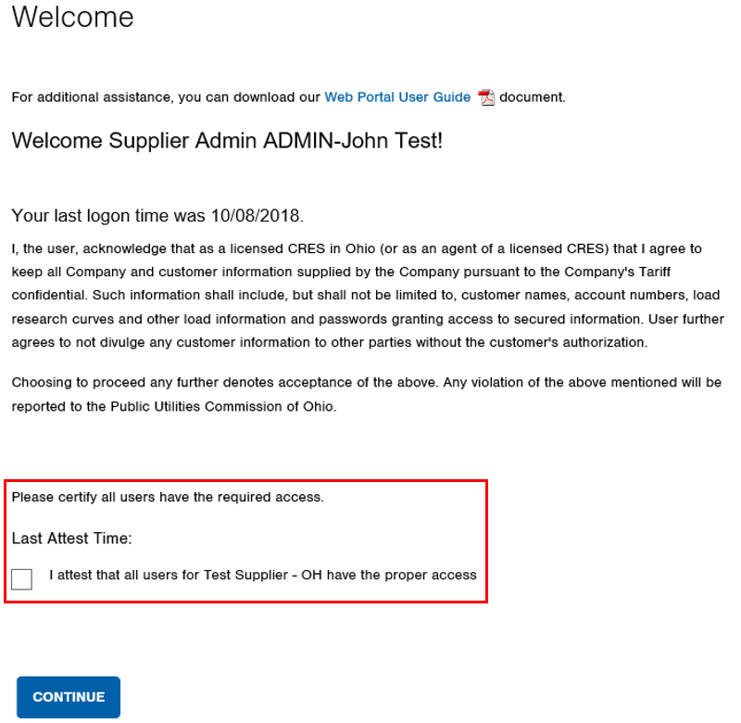
Figure 10 Attest

This prompt will be presented to the administrator upon initial login. Administrators can attest as frequently as they would like by selecting ‘Attest Access’ from the Admin page, however they will be prompted at login as they get close to the 3-month limit.
Note: If the administrator does not attest for a period of 3 months, both the administrator and all users of the tool will be locked out. The administrator must reach out to supplier services to unlock the portal.

Activity Log
The Activity Log is located on the left-hand side of the web page (Figure 11). The date, time, user ID, action code, and action text will be provided in the log and can be exported to Excel.

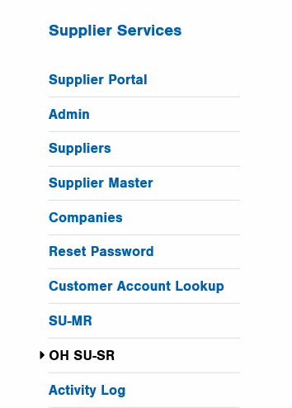
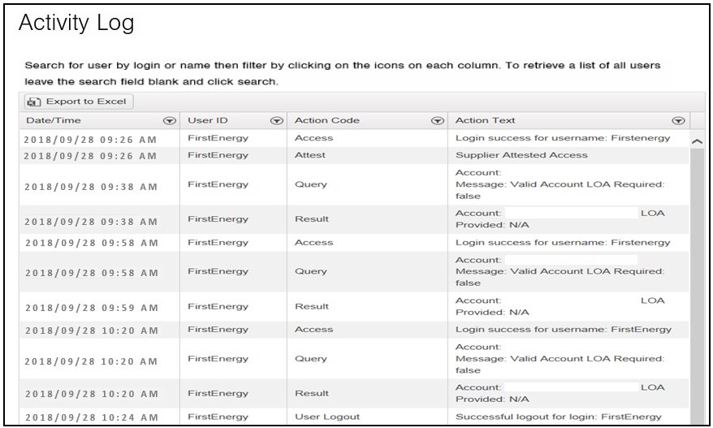

Figure 11 Activity Log

Single User – Single Request (SU-SR) Access

According to the Web Portal Working Group Technical Implementation Standards a Single User – Single Request (SU-SR) requires a web-based platform allowing for an authorized user to manually log into a secure portal, request, and receive usage data for one account number.

A user will log in using the following URL:
https://www.firstenergycorp.com/supplierservices/supplier_portal.html

After successful log in, a welcome page will be presented (Figure 12). This page explains the importance of confidentiality and customer authorization when using the portal. A pdf version of this user guide can also be accessed from this page.

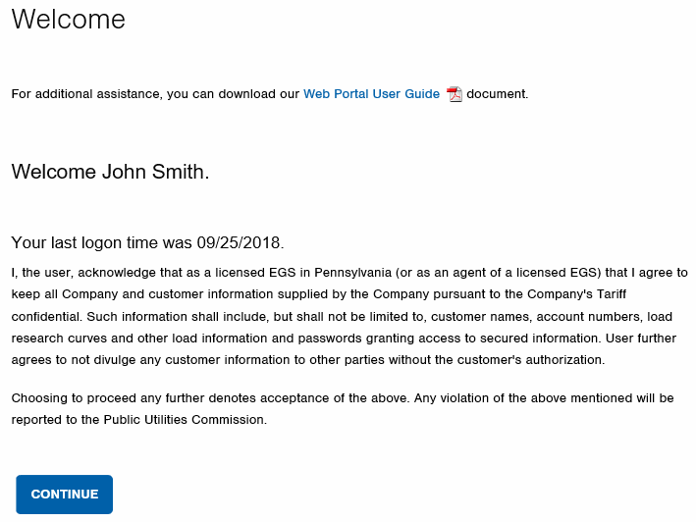
A link to the Portal User Guide is available from this page
Select continue to access the portal

Figure 12 Welcome Page

Select the OH SU-SR transaction from the navigation menu to launch the initial screen (Figure 13):

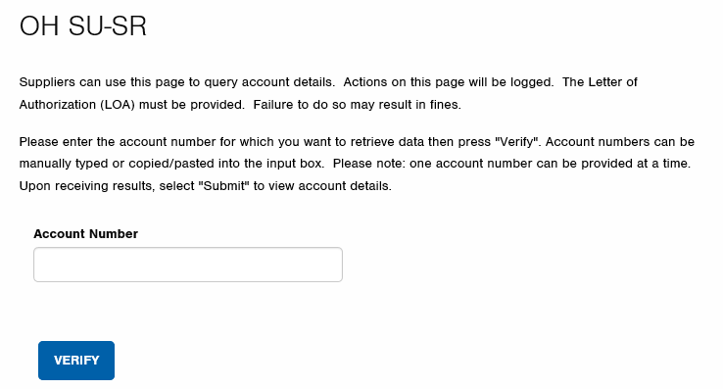

Figure 13 OH SU-SR

Once the account is entered the user would then select verify. This will allow the account to go through a verification and could prompt an error message (Figure 14).

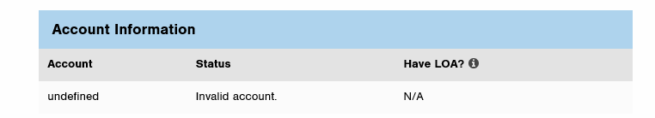

Figure 14 Account Table Error Message

The table below provides a list of rejection reasons:

Rejection Reason | Summary of Rejection
Missing Account Number | Input is missing 20-digits
Invalid Account | Input has 20-digits, but the account is not recognized
Accounts Exists but is not Active | Account is final or has a pending move out date
Unmetered Account | Account does not have metered usage
Account Pending Active | Request was made before the move in date
Historical Usage Unavailable | No historical usage is available

After verification a Letter of Authorization (LOA) must be attached (Figure 15). The user can use the Browse button to search their computer and attach the customer authorized letter.

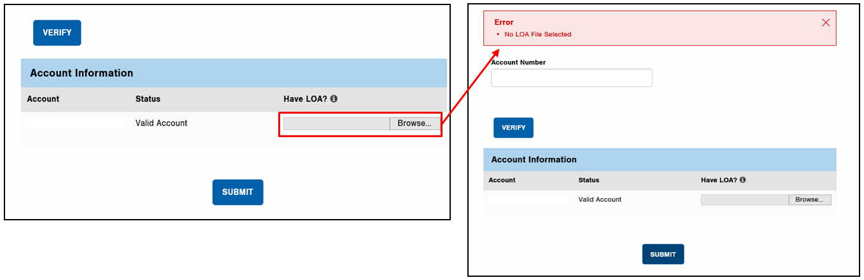
Figure 15 LOA

Note: An LOA must be attached each time account information is requested.

Single User – Single Request (SU-SR) Usage Information

Once the letter is attached and submit is selected, the following online view of an account’s data response is presented (Figure 16):
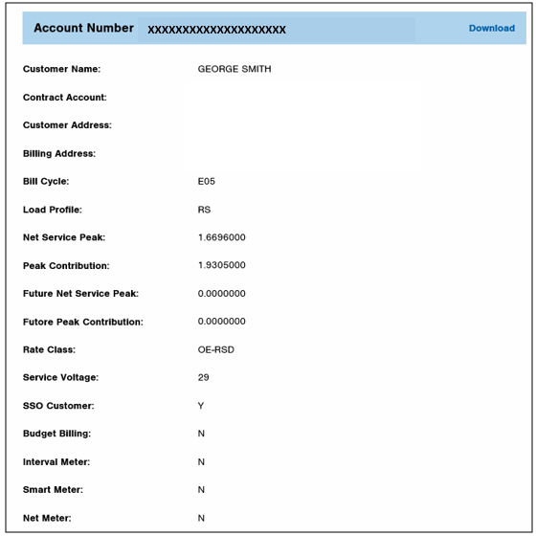
Use download button to export file
xxxxxxxxxxxxxxxxxxxx
123 Main St. Akron OH 44308
123 Main St. Akron OH 44308
George Jones

Figure 16 Account Attributes

The following customer information will be presented, when applicable:
- Name  - Account number  - Service Address  - Billing Address  - Bill cycle  - Load profile  - Net service peak  - Peak contribution  - Future net service peak | - Future peak contribution  - Rate class  - Service voltage  - SSO customer  - Budget billing  - Interval meter  - Smart meter  - Net meter

12 months usage is also provided:
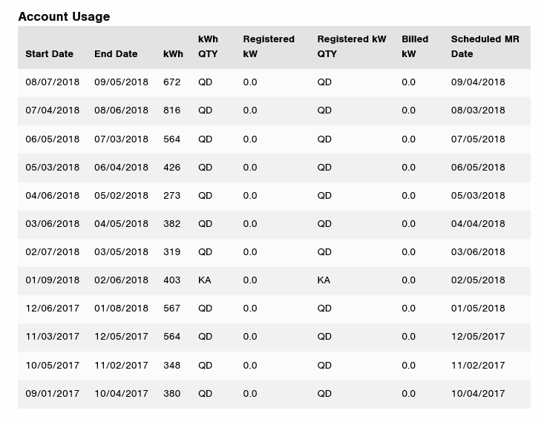
Figure 17 Usage Summary

If the account has multiple meters, 12 months of usage history will display for both meters.

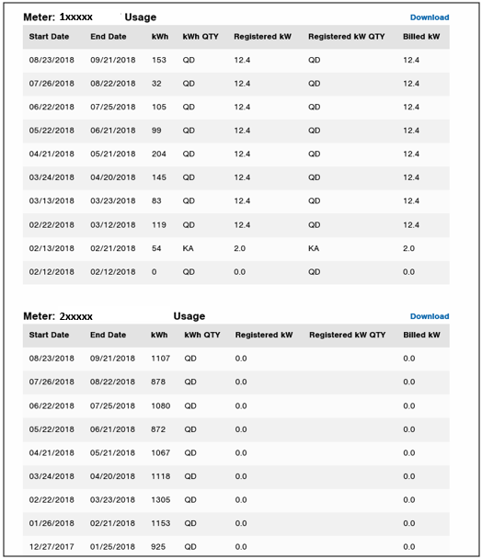
Figure 18 Usage Summary Multiple Meters
Tip: To navigate back to the SU-SR homepage to enter another account simply select OH SU-SR from the navigation menu.

Exporting SU-SR Data

A file of the usage data can be downloaded by selecting the Download button at the top of the screen.

Figure 19 Account Level Download

If the account has multiple meters, selecting the download button listed near the usage history will return information for the specified meter only. To see usage for all meters, select the download button shown above.

Figure 20 Meter Level Download

Downloading information is useful if interval data is available as this will not show on the portal page (Figure 21). Additional information on this page includes:
- Meter number
- Meter type
- Meter multiplier
If the user needs the information saved or organized differently than what’s presented, they may wish to download to Excel also.

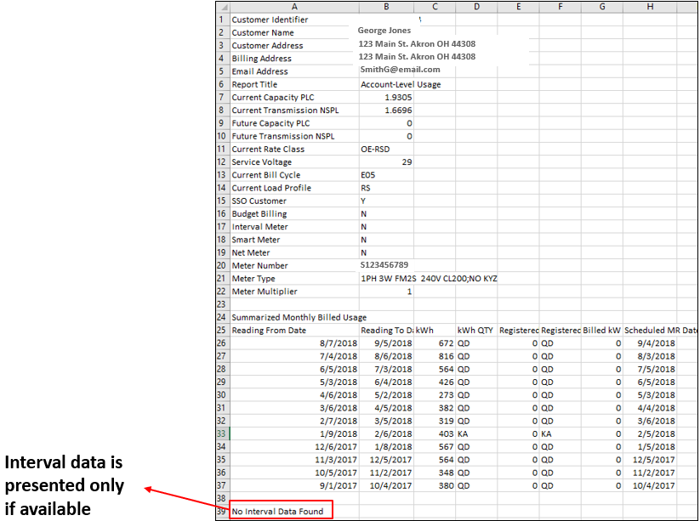

Figure 21 Export Information
Downloaded information with interval data:

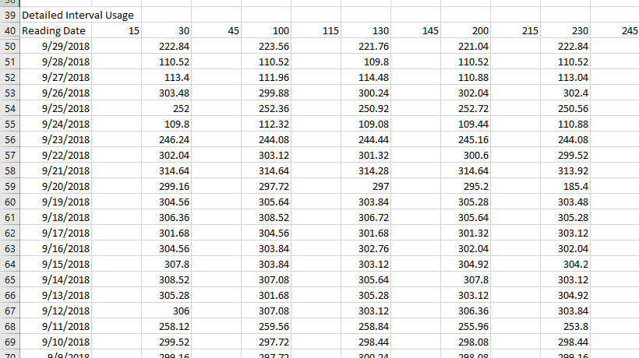

Figure 22 Export with Interval Data

Logging Out

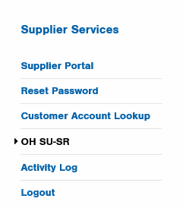
You should log out at the end of each working session to disconnect with the portal. To do this, select Logout from the left navigation menu (Figure 23).
Figure 23 Log Out

If you forget to select logout at the end of a session the system will lock you out if you try to go back in (Figure 24). The following message will display:

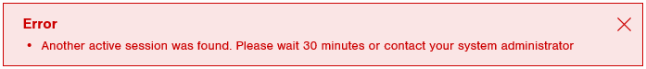
Figure 24 Locked Out Error

If you have been inactive for 30 consecutive minutes the web portal will require you to log in again. A user can contact your organizations Administrator to ‘deactivate session’ or wait 30 minutes.

